Chapter 1
Automated Categorization & Mining Tweets for Disaster Management

Rakhi Patra¹,
Mtech BITS Pilani, Kolkata-700156

¹Rakhi.Patra@gmail.com,

Abstract. Recent trend has shown that Twitter is an emerging source to monitor disaster events. This article aims at mining tweet messages to facilitate disaster manager for better response in times emergency. The two main objectives here are classification and extraction of tweets. In this work machine learning is applied on tweets that are generated during the course of a disaster, to categorize them into different stages of that disaster and extract the metadata. An initial effort has spent for manually labelling 1,000 tweet messages into predefined categories according to disaster phases to build the classification model. Thereafter, the trained model is used to automatically categorize the new subsequent tweets in a supervised way of machine learning. The five classes or categories are considered in this work are as preparedness, response, impact, recovery and other. Once the classification is done, next objective is to mine information from the categorized tweet messages such as impacted locations, hardest hit areas, volunteer relief organization who are working on, whether that message is a complain, if any disease has spread etc. The result generated after classification and extraction helps emergency manager so that they can take action quickly and efficiently in the impacted location.

Keywords: Twitter; disaster; text mining; data mining; disaster coordination; disaster relief

Introduction
Since past few years, uses of social media service has been growing rapidly as a standard medium for faster communication, especially in the age where people are always connected on mobiles unlike traditional newspaper & TV. Popular social media includes Twitter, Face book, YouTube etc. Twitter is a real time micro blogging network which provides a platform where users can post their view and information’s called tweets. In times of disasters like cyclone, earthquake Twitter plays a major role in rapid spreading of messages by posting early alerts and warnings, live updates of emergency situations on-the-ground like magnitude of the disaster, loss & impact, damage severity. People tend to use social media for several reasons to check on family and friends, seek support, gather news on daily updates on weather, safe locations and food & water supplies, send donations etc. Thus Twitter can help to track natural disasters in real time. It notify emergency to areas that need urgent aid.
In several countries in Asia, public, government agencies, nongovernmental organizations (NGOs), and ad-hoc volunteer groups use Twitter to share, exchange and collaborate critical information and organize relief efforts in times of crisis. Twitter improve relief and rescue operation by mining actionable data from tweet messages. However, manual examination of millions of unstructured tweet posts is a big challenge in time of crisis. Purpose of this study is to apply supervised machine learning technique to understand & analyze the tweets, posted in the time span of a disaster and classify them according to disaster stages. Classified tweets help emergency managers to understand the transition between stages that save their time to organize information, and set priorities and activities during the course of a disaster. Tweet mining is the next step to identify the hardest hit areas , people in the most need, to understand challenges, damages & impacts so that emergency manager, rescue workers can streamline activities accordingly.
This paper presents a tweet analysis framework that is built with IBM NLP & NLU API. With this framework, relevant tweets are categorized and mined extracted from the raw tweet text.

The subsequent sections of this paper are structured as follows. Section 2 is a general review of the research on using social media in a disaster, followed by the section 3 describing the methodology for preparing and mining tweets for disaster analysis. Sec 4 focus on how to apply the classifier on new tweets and validating the results. The paper is concluded with a discussion of the issues, challenges and future research directions of using social media data for disaster analysis and study.

Related works
Social Media has redefined and revolutionized the communication in time of crisis. Recently, in many studies social media data are processed for damage assessment, analysis people’s response, and coordination of relief efforts.
Regarding the contribution of social media in flooding management, Madhu Bala, K. Navya, & P. Shruthilaya^{[1]} described how tweet post are processed for polarity classification and irony detection, to facilitate disaster managers for better response operations. In their work, they emphasize on tweets with negative polarity that have additional probability to contain information concerning dangers or emergency things within the context of a natural disaster. They used KNN machine learning for sentiment analysis. In their study final outcomes are presented in form of word cloud derived from tweet posts, bar graph of location wise tweets, and polarity score of sentiment on disaster response. They validated the result on 2015 Chennai flood data.
For wildfire risk management, Nikos Athanasis and Marinos Themistocleous ^{[2]}, proposed a fire behavior prediction system by processing tweet messages & their geographic location. In their proposed methodology, they used Apache Kafka open source message queue storage to process tweet stream data and Hadoop a distributed big data search and analytics engine. For identifying messages containing relevant to the incident information, they used keyword based filtration of Twitter messages that is common practice in the analysis of Twitter messages. They built a REST API to query inside the ElasticSearch big data store, to exclude the off-topic messages and visualize the meaningful messages through the web-based GIS visualization platform.
The work of Meera.R.Nair ^{[3]} mainly focused on the 2015 Chennai Flood in India. Here tweets regarding flood were retrieved with the help of the keyword #chennaiflood along with 17 attributes. The tweets with 17 attributes were given as input to Weka, a free data mining analytical tool for classification, clustering, data preprocessing and visualization. Tweets collected have been classified using machine learning algorithms such as Decision trees, Random Forests and Naive Bayes. Performances of all the three algorithms are compared in terms of Precision, Recall and F-measure. The tweets obtained mainly fall into 5 categories that include Need for help, Relief Measures, Express Gratitude, Complaints and Other. This study also identifies the most influential users of Chennai flood on the basis of count of tweets, retweets and the followers that each user has.

Qunying Huang and Yu Xiao, define a list of message categories that are involved in each disaster phase. They also explore spatiotemporal pattern of people’s behaviors and reactions by mapping the geographic locations of tweets of a specific category.

The intent of this work here is to highlight the role to twitter in real time disaster management. This work focuses on tweets regarding the cyclone.
In this work the tweets are categorized according to disaster stages. Compared to similar studies, the added value is by mining tweets to find insights such as impacted location, company or organization, if disease spreads in affected area etc .

Methodology
Here the proposed framework consists of two main parts: classification and extraction. As the core technology of this framework, IBM Watson Natural Language classifier(NLC) and Watson Natural Language Understanding Service (NLU) are used to leverage the advanced natural language processing techniques to create a powerful tweet classifier. NLC helps user to classify short text inputs into predefined categories, at scale. IBM NLC combines various advanced machine learning techniques to provide the highest accuracy possible, without requiring a lot of training data. Whereas NLU can analyse text and extract meta-data unstructured tweet text such as concepts, entities, keywords, categories, sentiment, emotion, relations, semantic roles. A cloud-based Watson Service, NLU comes with a simple to use API framework.
In the solution , classifier and extractor are combined and delivered as a cloud based service with simple to use API.

Training Data

In this work, cyclone Fani, which hit the state Odisha in India on 1st May 2019, is selected to create the training model. Tweets with hash tag ‘cyclonefani’ are examined. Cyclone Fani was formed since 26 April 2019 and dissipated 5 May 2019. In order to understand the type of information that has been spread in Twitter before, during and after the disaster, tweets which were posted in the time span of 26th April to 26th May 2019, are retrieved with the help of the keyword #cyclonefani. Tweet messages are retrieved from the Twitter Source by utilizing the Twitter API with predefined has tag for a specified date range. Tweets are then dumped into a text file.

Tweet Categories

A total of 1,000 tweets were collected for this work. To determine the categories of tweets obtained, each message is manually examined based on specific keywords relevant to the context of disaster phase that is a common practice in the analysis of Twitter messages. To decide the disaster phase I refer official government procedures [2,3]. Government disaster management process has defined disasters into four stages a) mitigation (prevention and risk reduction), b) preparedness, c) response (immediate rescue) and d) recovery (build-back better). However, mitigation is not considered in this work. Because tweets of this category are less in count as it concerns the long-term measures to prevent future disasters or minimize their effects. This paper primarily focuses on other three phases. I additionally identified category Impact, that focuses tweets on impact, hit areas, damage & loss, which is crucial for disaster response. There are many tweet posts that report ironic comments, general comments, expressing gratitude don't seem to be significantly relevant in the context situational awareness. Therefore, a category called “other” is defined to describe such type of messages.

The five classes or categories considered in this work are as follows:

- Preparedness
This category contains tweets regarding early alerts, warning, emergency plans,; such as evacuation, shelter, stock up.

- Response - This category includes messages that indicates immediate rescue & relief operations, any kind of announcement from airport authority for free shipping of relief aids such as supply of foods, medicines, doctors. If any kind of disease spreads like fever, diarrhea.

- Impact – This category includes messages aftermath, damage measure.

- Recovery – Rebuild

- Other - This category includes all other messages like lost and found, general comments and expression of opinions.

Train the Classifier Model

During the initial annotation process, I notice that most of the tweets are fallen into others category, and some categories contain only a very small number of tweets. Sampling set is prepared by ensuring that each category should have enough tweets to build a successful classification model for the predefined categories. IBM Watson natural language classifier (NLC) is used here to meet the classification goals. In the NLC model builder, classes are predefined and text examples are added. NLC accepts the example data in a .csv file format to train the model. Once the category of each tweet is determined, the initial text file of collected tweets, is saved as a csv format as {tweet-text, category}.This csv is then feed to NLC as an input to train the classifier model. Once training model has been created successfully it is used predict the category of the new tweets.

Tweet Extraction

After classification, tweets are further mined to retrieve useful information from tweet text for disaster analysis. Here tweets are processed by IBM cloud’s natural language understanding (NLU) in order to extract text analytics features like sentiment, location, organization/company, topic etc. Relevant features in context of this works are discussed below with examples.

- Sentiment – Negative sentiments are considered as complaints.

e.g. : Diarrhoea cases on rise in # CycloneFani ravaged # Puri District, which is still battling to overcome the crisis.

- Location – Any location entity used in tweet post.

Cyclonic storm # Fani now 670 km east to Potuvil. Cloudy skies over most parts of # SriLanka. Rains or thundershowers in Western, Southern, Sabaragamuwa, North-Western and Central provinces. Heavy Rains 100mm at some places - MET # LKA # WeatherSL # CycloneFani pic.twitter.com/pPVZZFxiup

- Organization/Company – If the tweet post contains name of the volunteer, NGO organization.

Air India: National carrier Air India steps forward to help the residents of Odisha affected by # CycloneFani . If any (NGO/ Civil society/ SHG etc) wants to send relief materials to cyclone affected area of Odisha, Air India would ship it free of cost.

ICICIBank today launched ‘Mobile ATM vans’ in association with @ bmcbbsr. The service was inaugurated by Ms. Ananya Das, IAS & Add. Commissioner, @ bmcbbsr and is specially organised to serve the people of the city till ATM normalcy is attained.

- Topic-

Diarrhoea cases on rise in # CycloneFani ravaged # Puri District, which is still battling to overcome the crisis.

CycloneFani in the Bay of Bengal is expected to strengthen as it moves northwards in the coming days. Uncertainty about landfall location at this stage. Nick pic.twitter.com/9yUeDzzXTk

Tweet message
Dump into .text file
Manually annotate categories
Train and build classifier model
Determine category of new tweets
Extract text analytics features like entities, location, company etc.
Classification
Extraction

Fig. 1 – Conceptual design of the proposed methodology

Fig. 2 – Architectural components of the proposed methodology

Results And Discussion

The classifier has been validated on tweets collected with hashtag #CycloneVayu, #CycloneTitli & NepalEarthquake.
Hash tags and date range are defined though a web based UI.

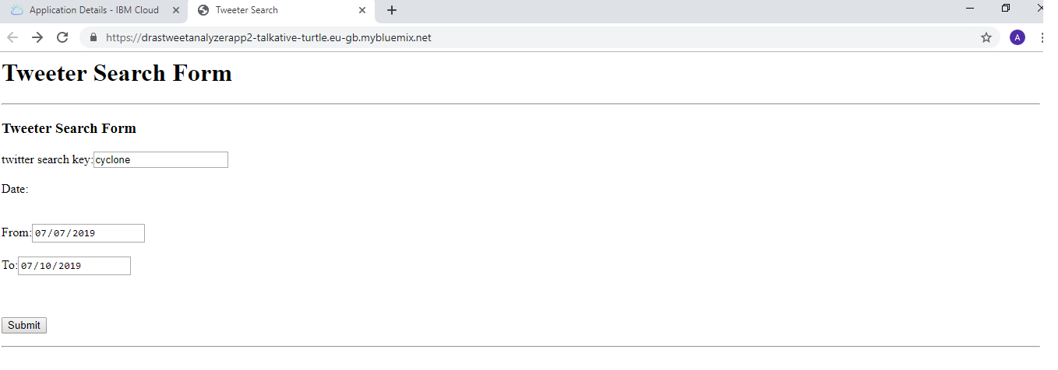

The consumer API is used to get out the classified and mined tweeter messages. Classification results are generated as expected. The result can be visualized in JSON format through a web browser based visualization platform.
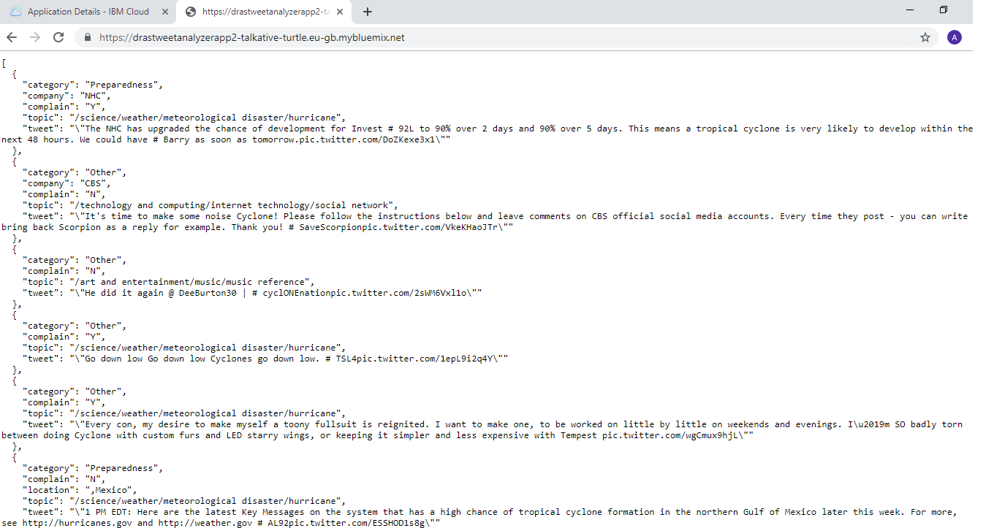

There is also an option available to download the result in excel format. Excel has five sheets according to disaster stages. Each sheet contains tweets of that category. To sum up the result, excel has fields such as if the message is complaint, impacted location, company or organization working on, if any disease spread.

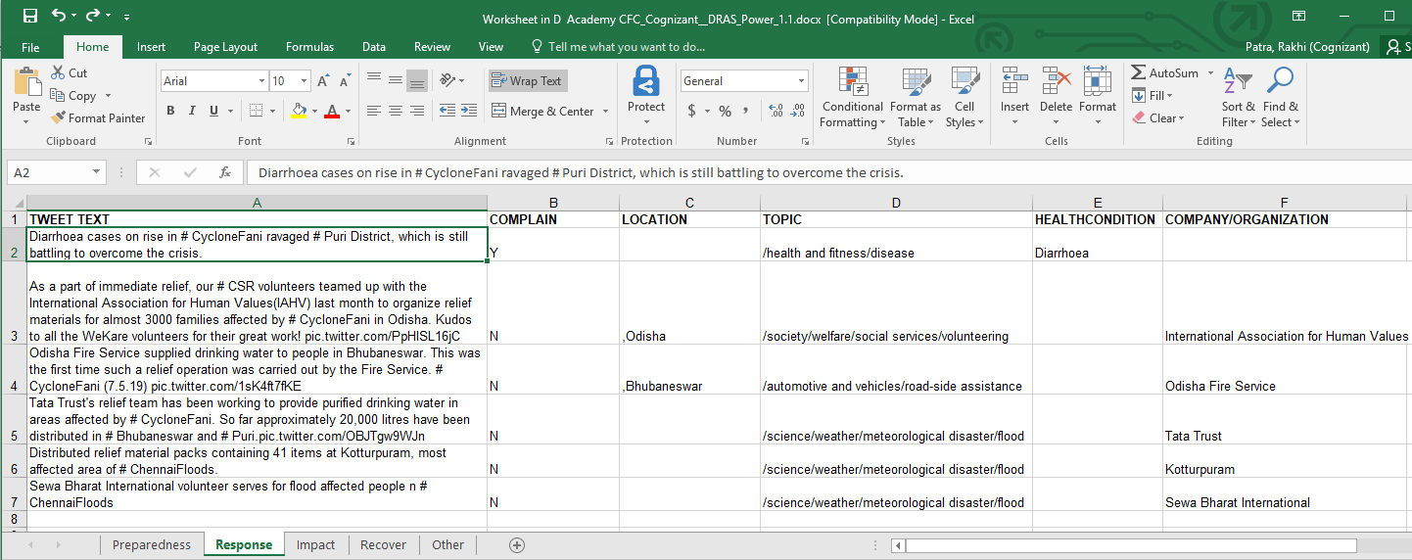

Conclusion
This paper presents classifier & mining model that could be used to automatically classify tweets of natural hazards, especially cyclone related ones. Thus the model could help, support real-time disaster management and analysis by monitoring subsequent events while tweets are streaming, and mining useful information.

Additional information from tweets like originator of tweets, user type (Individuals, Celebrities, Journalists, News organizations, Government or NGOs), date & time of tweets could. Our goal is to run the tweet classifier program as a continuous process during a disaster outbreak which will capture whenever a new tweet is posted. Timing and other inputs should be configurable from UI. Future plan extend the functionalities by adding damage severity assessment by analyzing the images posted with tweet messages.
References
- Myneni Madhu Bala, K. Navya. P. Shruthilaya, TEXT MINING ON REAL TIME TWITTER DATA FOR DISASTER RESPONSE. International Journal of Civil Engineering and Technology (IJCIET), 27(11).
- Nikos Athanasis1,*, Marinos Themistocleous1, Kostas Kalabokidis2
Apostolos Papakonstantinou2, Nikos Soulakellis2, Palaiologos Palaiologou3 THE EMERGENCE OF SOCIAL MEDIA FOR NATURAL DISASTERS MANAGEMENT: A BIG DATA PERSPECTIVE. The International Archives of the Photogrammetry, Remote Sensing and Spatial Information Sciences, Volume XLII-3/W4, 2018
GeoInformation For Disaster Management (Gi4DM), 18–21 March 2018, Istanbul, Turkey
- Meera.R.Nair1, G.R.Ramya1,P.Bagavathi Sivakumar. Usage and analysis of Twitter during 2015 Chennai flood towards disaster management. 7th International Conference on Advances in Computing & Communications, ICACC-2017,22-24 August 2017, Cochin, India
- Qunying Huang 1,* and Yu Xiao, Geographic Situational Awareness: Mining Tweets for Disaster Preparedness, Emergency Response, Impact, and Recovery. ISPRS International Journal of Geo Information ,ISSN 2220,9964
- https://ndma.gov.in/images/policyplan/dmplan/National%20Disaster%20Management%20Plan%20May%202016.pdf
- https://www.undp.org/content/dam/india/docs/disaster_management_in_india.pdf

